Finalist of the Innovation Award Laser Technology 2012

Excimer lasers for Active-Matrix-LCD and Active-Matrix-OLED based flat panel displays



Dipl.-Ing. Rainer Pätzel
Director of Marketing
Coherent GmbH
Göttingen

Members of the project team
Dipl.-Ing. Rainer Pätzel, Director of Marketing, (team representative),
Coherent GmbH, Göttingen
Dr. Kai Schmidt, Director Research and Development, Coherent GmbH, Göttingen
Dr. Ralph Delmdahl, Product Marketing Manager, Coherent GmbH, Göttingen
Dipl.-Ing. Andreas Targsdorf, Pulser Development Team Leader, Coherent GmbH, Göttingen
Dr. Igor Bragin, Laser Tube Development, Team Leader, Coherent GmbH, Göttingen
Dipl.-Phys. Frank Simon, Beam Delivery Systems, Team Leader, Coherent GmbH, Göttingen
Dipl.-Ing. Ludolf Herbst, Product Line Manager, Coherent GmbH, Göttingen

Areas of application
Major sectors of industry which are profiting from the innovation:
- Flat Panel Display Industry
- Microelectronics Industry

Technological impact
- Reduced manufacturing costs for existing products
- Improved quality in existing products
- New products
- Reduced process costs

Abstract
Flat panel display manufacturers face demand for features such as decreasing power consumption, faster response times, enhanced contrast and better resolution which exceeds the performance limits of conventional amorphous silicon backplanes. High performance touch displays of smartphones and tablets, in particular rely on ever smaller and faster switching thin film transistors and therefore require sufficient electron mobility of the conducting silicone backplane.
Excimer Laser Annealing (ELA) is the enabling process step for converting the amorphous silicon (a-Si) to polycrystalline silicon (p-Si) which provides more than hundred times higher electron mobility. Technically, a 308 nm excimer laser line beam is scanned over a thin (typical 50 nm) a-Si film, which absorbs the UV radiation, partially melts the surface, and subsequent recrystallization leads to the formation of Low Temperature Poly-Silicon (LTPS). The line beam has a final homogeneity of 1.8% (2 σ) to allow 10 to 20 overlapping irradiations of each location with the same fluence when scanning the substrate. The ELA process is performed at low temperature, eliminating the need for expensive glass substrates.
Until recently the majority of high performance LTPS displays using AM-LCD or AM-OLED were manufactured on generation 4 backplanes employing 500 W-class excimer lasers feeding 465 mm line beam optical systems. In the latest ELA system state of the art cylindrical optics deliver a homogeneous line beam with dimension 750 mm X 0.4 mm enabling generation 6 substrate annealing. The result is a backplane with very homogeneous 50 nm film of polysilicon of approximately 0.3 μm x 0.3 μm grain size providing 150 cm²/Vs which is two orders of magnitude higher than the electron mobility of amorphous silicon backplane.

Therefore the task was to develop a high power 308 nm excimer laser with pulse repetition rate of 600 Hz and stabilized output power of 1.2 kW which provides fast cycle-times. The output power of 1.2 kW was achieved by spatially merging and temporally synchronizing two high power UV-oscillators each capable of 1 Joule energy per pulse and 600 Hz pulse frequency. In addition to the resulting dual-oscillator laser platform called VYPER a novel beam delivery concept had to be developed for beam forming, mixing, homogenizing and projecting the incoming laser beams into one homogeneous line beam.

The new 308 nm excimer lasers are the key to faster, brighter and thinner AM-LCD and AM-OLED flat panel devices and thus for example to the fabrication of large OLED-TV displays of up to 55inch diameter. By transforming their production lines from generation 4 to 6 panel size, flat panel display manufacturers are able to increase throughput and decrease unit costs by up to a factor 4.
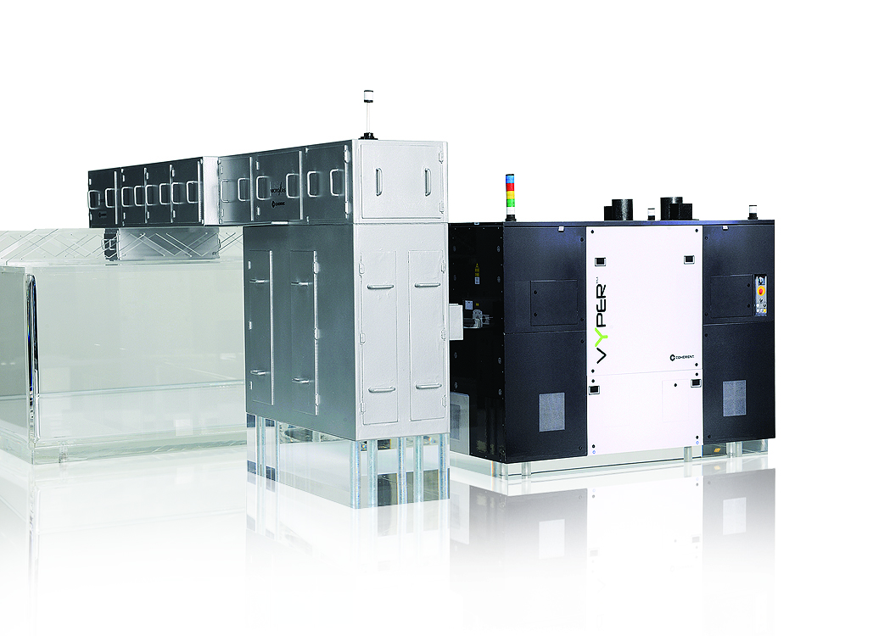

Figure 1: High power 308 nm excimer laser VYPER with pulse repetition rate of 600 Hz
and stabilized output power of 1.2 kW integrated in a LineBeam System
(Photo: Coherent GmbH, Göttingen)

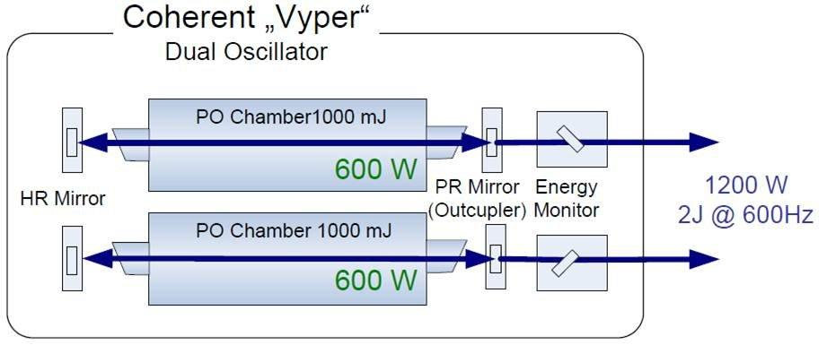

Figure 2: Dual-oscillator laser platform for high power excimer laser VYPER
(Photo: Coherent GmbH, Göttingen)

